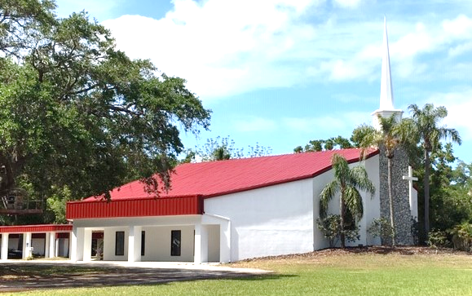
December 22, 2019

Hope

Presbyterian Family News

GUEST PREACHERS
For December:
Clem Street Tuesday 12/24.
Neddy Astudillo Jan 5 and Jan 12
The children and youth are planning and will lead the service for December 29. It will be a wonderful month of worship at Hope.
GUEST PREACHER
Amy Santamaria was raised in Virginia and has lived in Mexico, California and now the Tampa Bay area. She spent 10 years as a volunteer missionary with the PC(USA). During that time, she attended San Francisco Theological Seminary, and also met and married her husband, Miguel. Together, they came to the Tampa Bay area 13 years ago, and have since been blessed with their three children, aged 10, 7 and 7. Amy serves as a chaplain at Tampa General Hospital, where her passion for accompanying those who are grieving meets her commitment to serving those on the margins. When she is not working, Amy loves to read, run, travel, and seek beauty through a camera's lens.
CONGREGATIONAL MEETING

There will be a called congregational meeting immediately after the service today, to hear a report from the Pastor Nominating Committee.
CHILDREN, KFC/CAYA CALENDAR

No KFC/CAYA today or 12/29
No Kids or Youth Sunday School 12/29; classes will resume 1/5/2020.
CE NEEDS YOU!

To build our programs and to provide our current students with the best experience possible, we need more input and more hands! We would love you to join us to discuss new projects at our next meeting, on Thursday Jan. 9th.
WORSHIP ON DECEMBER 29TH

The Worship Service next Sunday, December 29th, was designed and will be led by Hope’s Children and Youth. Back in October, the students began learning about the different types of prayer in a typical service, the purpose of the songs, and even determined a central theme around which to build their service. Each week the students learned about and prepared a different element of their service, and they are so excited to share their work with you! Please make every effort to attend worship at the normal time (10:15am) next Sunday to enjoy what the Children and Youth have prepared for you!
A TINY TREE IN PORTUGAL

Walking home from work on a cold winter’s night, Ernesto (Maria Leonor and Antonieta's father) stopped at a store and bought a tiny tree and some decorations. He called Andrea to keep the girls up for his arrival.
Five months earlier they had left Venezuela with a suitcase for each family member. They had to leave everything else. There was no room for Christmas things.
When he came into their apartment, the girls saw the tiny tree, and as Andrea described it "They had the biggest smiles on their faces." The girls jumped and sang as they decorated tree. You can see the Wonder of Christmas and the joy they were feeling.
This will be their first Christmas in their new country of Portugal. We are so blessed to have them there safe and happy.
Thank you all for your giving and prayers. Feliz Navidad!
Beth and Len Dahlvik
CHRISTMAS PARTY WAS A BLAST!
The Children and Youth had their Christmas Party last Sunday after worship. After making cards and ornaments for their friends who couldn’t make it, the crew exchanged their Secret Santa presents. Everyone was very excited! They then enjoyed lunch at McDonald’s followed by a trip to the movies to see Frozen 2! A wonderful time was had by all! On behalf of all the Children and Youth, thank you for your support! May you have a wonderful and safe Christmas holiday!
KFC JANUARY FUN
Happy New Year! The new year brings new beginnings; a time to change your ways. The KFC kids will be learning all about New Year’s resolutions and how to keep them. The theme is all about prayer. When to pray, how to pray, what to pray, and where to pray. We will be learning about praying properly and how to keep God with them throughout the day every day. We will be making prayer devotional journals so the kids can find a quiet time with God, giving their worries and fears to Him.
Philippians 4:6
Don’t worry about anything but pray about everything. With thankful hearts offer up your prayers and requests to God.
Hope everybody will have a Merry Christmas and a Happy New Year.
Amy Belden

Tues. Dec 24 Christmas Eve Service 6:00 p.m.
Office Closed
Wed. Dec. 25 Merry Christmas No WNA, Bells or Choir
Office Closed
Sun. Dec. 29 Kid and Youth Sunday service 10:15 a.m.
Tue. Dec. 31 Office Closed
Wed. Jan. 01 Office Closed
No WNA, Bells or Choir

CHURCH EVENTS COMING UP

Contact US
Tel: 727.531.3200
office@hopefamily.com
Listen to sermons at
www.hopefamily.com

